**[Final Slide Deck Presentation Video](https://youtu.be/ucvKVrCtKtY)**

[**Final Slide Deck Presentation**](https://aquoco-my.sharepoint.com/:p:/g/personal/evoingram_aquoco_onmicrosoft_com/EYdRBEx9Wk9KuqGbxTX1QGsBGeDu_ewG5CF02SHvr8TL4A?e=L8wjJZ)

* **Describe in detail the favorite feature that you built, designed or delivered as a member of your project team. Please include links to a Figma file, pull-requests or link to a file in a** **repository that outlines the work you did on this feature.**

My favorite part of this project was helping manage it and testing it. My favorite feature was probably a tie between the search filter and the public page for non-Swaap users. I didn't work on the Public Page personally, but our user flow looked something like this when the team started working on it.

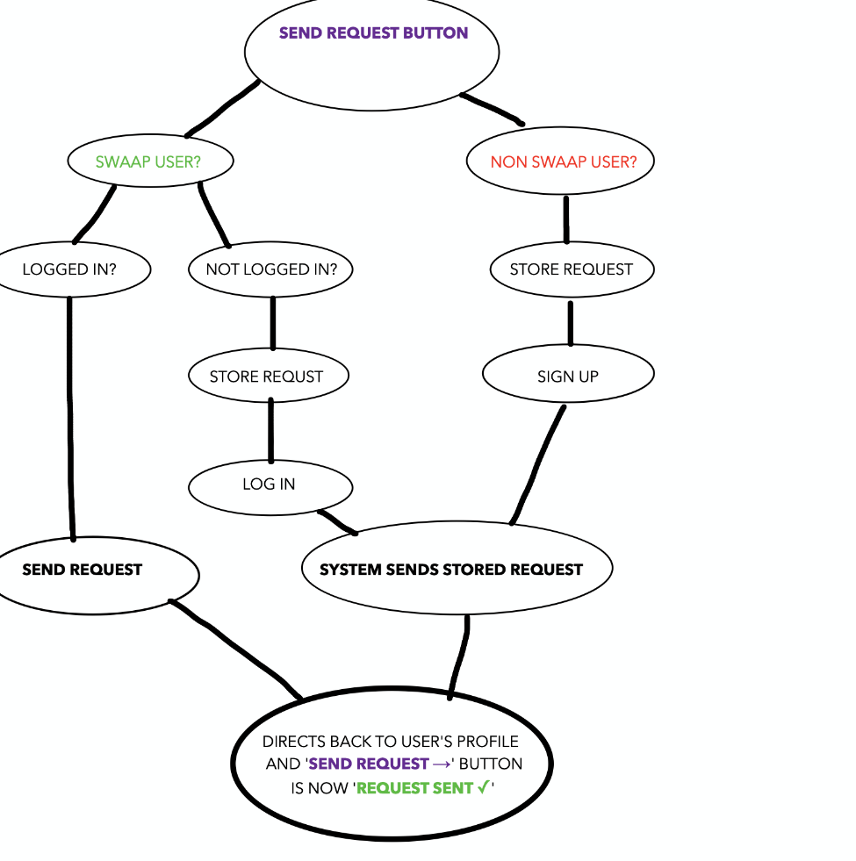

**Search Filter:** [**Pull Request**](https://github.com/Lambda-School-Labs/conference-contacts-fe/pull/82) **|** [**Trello Card**](https://trello.com/c/sb6YbBiX/58-filter-feature-on-contact-list)

**Public Page:** [**Pull Request**](https://github.com/Lambda-School-Labs/conference-contacts-fe/pull/77) **|** [**Trello Card**](https://trello.com/c/xyhD09Jc/43-edit-profile-page-refactor)

As for the search filter, it looked like this when complete:

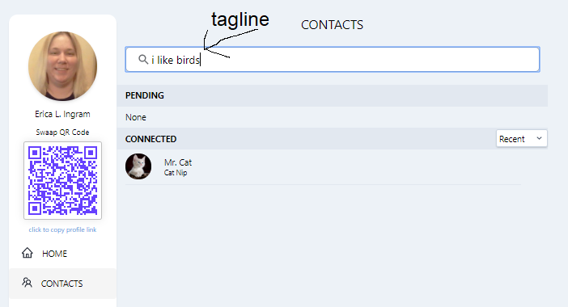

It wasn't terribly difficult because I've made a point to do a lot of search filters/boxes while here at Lambda, frankly. But one thing I did struggle with a lot was having to filter the array within the array. I ended up with a fairly hacky solution, but it did solve the problem. It's not reusable in terms of the size of the subarray, but it worked. Basically, I had to traverse a five-item array within each item of the overall search results array and, the way the filter was already written, I ended up just adding indexes 0 through 4 to it, although I really would have preferred another method, like not tying it to that subarray being five items long.

Also, the data from the API calI was built a certain way and drilling down into it and traversing it was difficult. I managed to get it five nested arrays (and thus loops) deep in a console log but couldn't translate that to the filter. I would add a loop, cnosole log to test what layer I was in, then repeat until I got to the part of the API data that I wanted. So although I almost got it, I spent three days trying to figure out how to make it reusable and ended up not being able to do that. I did ask the group about this and we couldn't figure it out. I feel like I was pretty close and given more time I might have been able to figure it out or if I could talk with someone with more experience than me, I might have gotten it worked out.

* **Describe the biggest hurdle you overcame technically or from a design perspective. Be specific in what the problem was and how you overcame it.**

Well, I just did! The other piece of this, the public profile page, was very complicated but I did not work on it. I did participate in the discussions leading up to the coding, though, and planning, and even just that flow chart is the result of several days of robust debate over how to implement something for non-Swaap users to entice them to come to Swaap. We worked really hard to get to that flow chart, made by Tristan. I don't remember exactly how many days, but it was pretty close to a full week and everybody participated. But after we did all that discussion, it was also moderately complicated to implement, I understand, from the continuing discussions of it after that.

* **Describe in detail the biggest 'inter-personal' conflict you overcame as a member of your project team. Be specific but please don't mention any team members by name.**

Working out the events integration in general caused a lot of friction, especially because we ended up having to drop it and none of us wanted to drop it. All of us really wanted to implement it, and we ended up not implementing it. What happened was some team members, I don't think purposefully, shut other people off from what they were doing, stopped communicating, and kind of did their own thing without telling anyone, which caused them to duplicate work others had already done, while not attending to the priority of the bottleneck they were supposed to fix in the first place. But I think the main cause of the friction was just general disappointment at having to settle and not being happy with the result. But we did all move past it and continue on. The next week, we didn't have that issue anymore.